Code Review: I2204257
Reviewer: James Wood
Date: March 15th, 2023
Bugs
- If the shipment fails to approve, we should not be running any of the follow-up code, reloading shipment, generating invoice, etc.
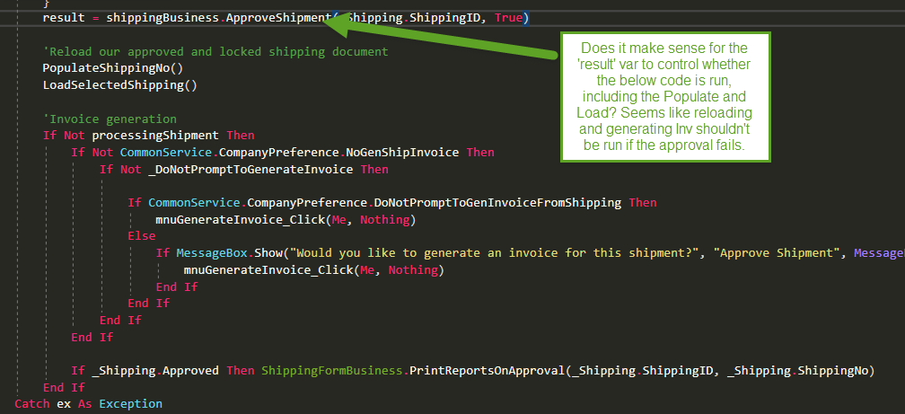
If ApproveShipment returns false, the function is now aborted.

- I think this should skip out of the Approval function if DataValidation fails:
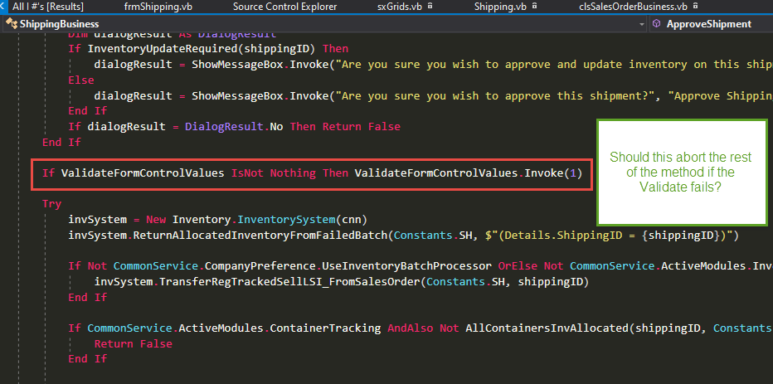
If ValidateFormControlValues returns false, the function now returns false.
Preventative Action/Safety
Design/Architecture (Duplication, appropriate project, namespaces, maintainability)
- Nit: Optional parameters and data type prefixes? I assume a straight copy of VB6 stuff.
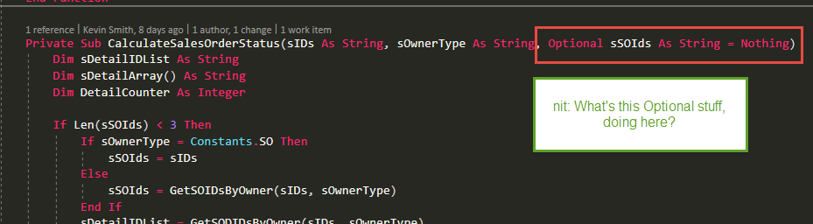
Optional parameters are a valid feature of VB. Their use should be accepted as long as they are not misused. That being said, this was copied from vb6, there was one reference to it, the parameter is no longer optional.

- Neat: These look like very useful functions that the whole codebase could benefit from. Are they not ready for the primetime in a more common location?
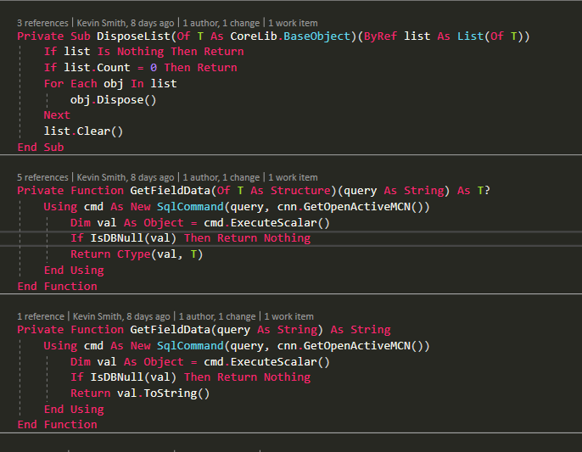
I feel like it is bad practice to use GetFieldData. I don’t want to encourage shortcuts. Use of GetFieldData was copied from vb6 as a shortcut…
You can move these to a new location if you want them. One is for simple types and nullables, the other for the object type of string. You may be able to create a single function that handles both. I did not take the time to look into it.

- I noticed this pattern on repeat. Could be extracted to a common location or at least to its own function in ShippingBiz.
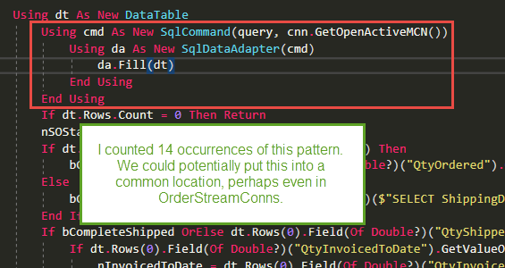
I find its usefulness minimal. As soon as you need a parameter in your query you cannot use this fixed pattern. It saves little code and obscures things.
I made it so regardless:
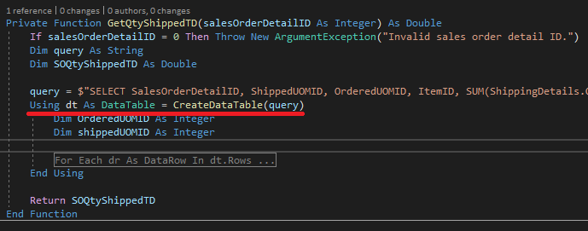

Is there a particular reason why the class and namespace were duplicated? To make it easier to see the new code?
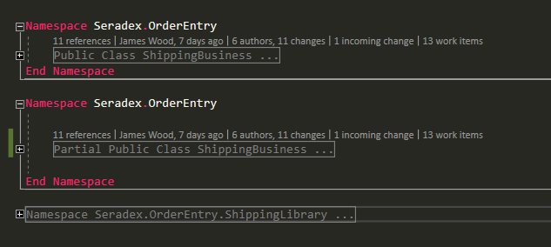
The namespace was closed and reopened to separate the new code from the old during development. The business class was extended to support approval.
- I wonder if we could have created an ApproveShipment class. That seems to basically be what this partial class represents. I see only one function that’s called from outside of the partial class and that’s called from the Approve function in Shipping.vb which looks like it’s no longer used.
  - Sure, the class is now ShippingApproval. There were a couple calls out to the existing ShippingBusiness, but they have been resolved.
Data Model(Naming, good design, needs index?)
Performance (Minimize DB hits, excessive loops, queries, scalable)
UI(Alignment, naming, standardization)
Error Handling(Behind events, appropriate parameter checking)
Cleanup (Dispose code, remove handlers, large data objects)
Readability (Well-named variables, methods, clear algorithm, is it understandable)
- Some minor readability and code stuff:
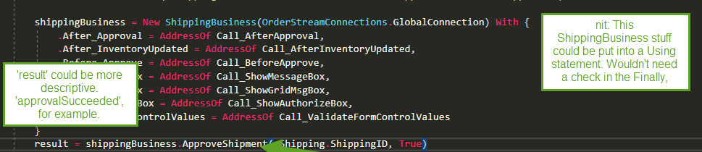
Result is not longer used, false is returned if ApproveShipment returns false.

- Another potential Using case:
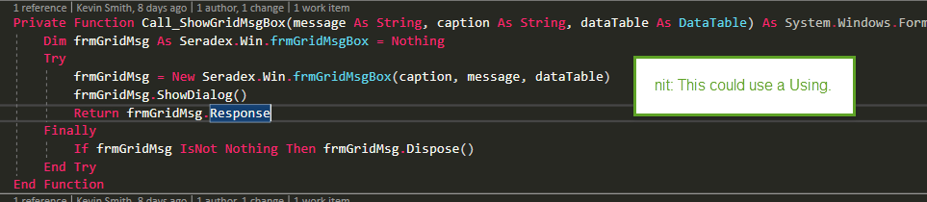
Nit: All windows forms have a built in DialogResult property which should be used instead of a custom Response property.

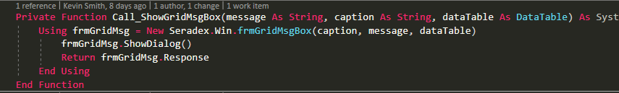
- Instance variable naming. We don’t have a standard, yet, but prefixing instance variables with an underscore helps with quickly identifying what’s what in a method.
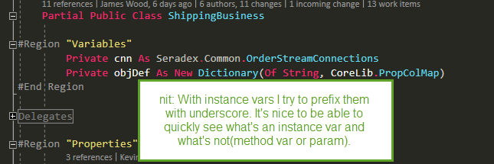
There are two standards in my mind. I have done neither here.
VB: Capital letters used for readability, underscore and ‘my’ used to differentiate access levels as VB is not case sensitive.
- Private _ObjDef as . . . ‘Class variable
- Public ObjDef as . . . ‘Class Property
- Dim myObjDef as . . . ‘Method variable
C#: Being case sensitive, capitals used for public, lower case for private/local
- . . . ObjDef { get; private set; } //Class property. Private properties used in place of class variables
- . . . objDef ‘Method variable
If you feel it is important, I am willing to implement underscores and ‘my’ prefixes.

- Spacing between important/different lines of code. Several instances of this but I’ll just put this example, here:
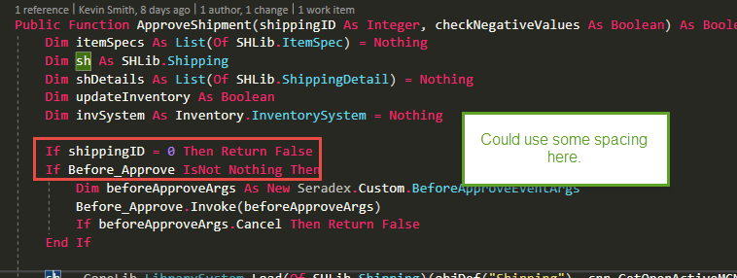
- Reading through that ApproveShipment method was a slog and a half. Trying to refactor it would be time consuming but this is probably the only time we’ll be able to do it. Seems like we could at least try to extract the validation code from the actual approval code. That would provide good value. Likely still time-consuming though, so not totally sure what to recommend. Perhaps this coincides with renaming/recreating an ApproveShipment class.
Are we talking about just the ApproveShipment mehod, or the full ride into RelieveInventory?
I don’t find the ApproveShipment too bad. The message boxes act as comments. This level of validation happens sequentially. It doesn’t flip between validation and processing. The processing is at the bottom. If you read into RelieveInventory, it becomes unclear what is happening and why. In its current state, we can at least compare with the working vb6 version almost 1:1, should there be problems.
I spoke with Chris. Getting off of vb6 is the priority. He is happy to keep the code as is until the vb6 version is completely replaced.

- Nit: When checking the results of a message box, I like to put the DialogResult condition before the messagebox call. Usually, those calls are quite long and can go off-screen. With the result check at the beginning all of those issues go away.
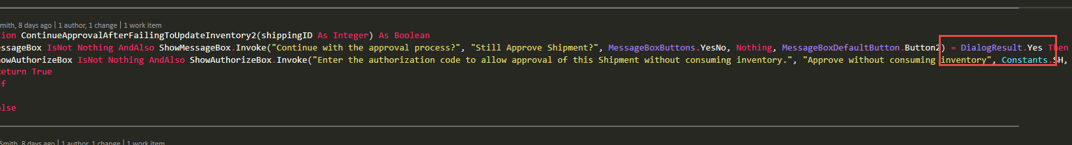
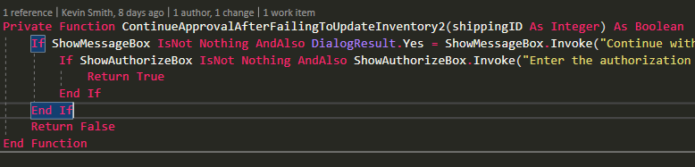
The way this reads might not be as clear in the logical sense, but you at least know what response you’re looking for immediately.
- Multiple data tables in a medium sized function without descriptive names:
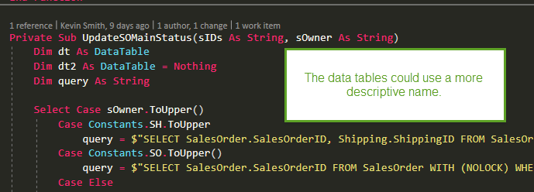
This was copied from vb6, where rs and rs2 were defined. They have been renamed dtHeader and dtDetail.
- A Public and Private region for the methods/functions is usually helpful.
- Nit: This could very much be personal preference, but I think the UpdateShipmentInventory function could use some structure.
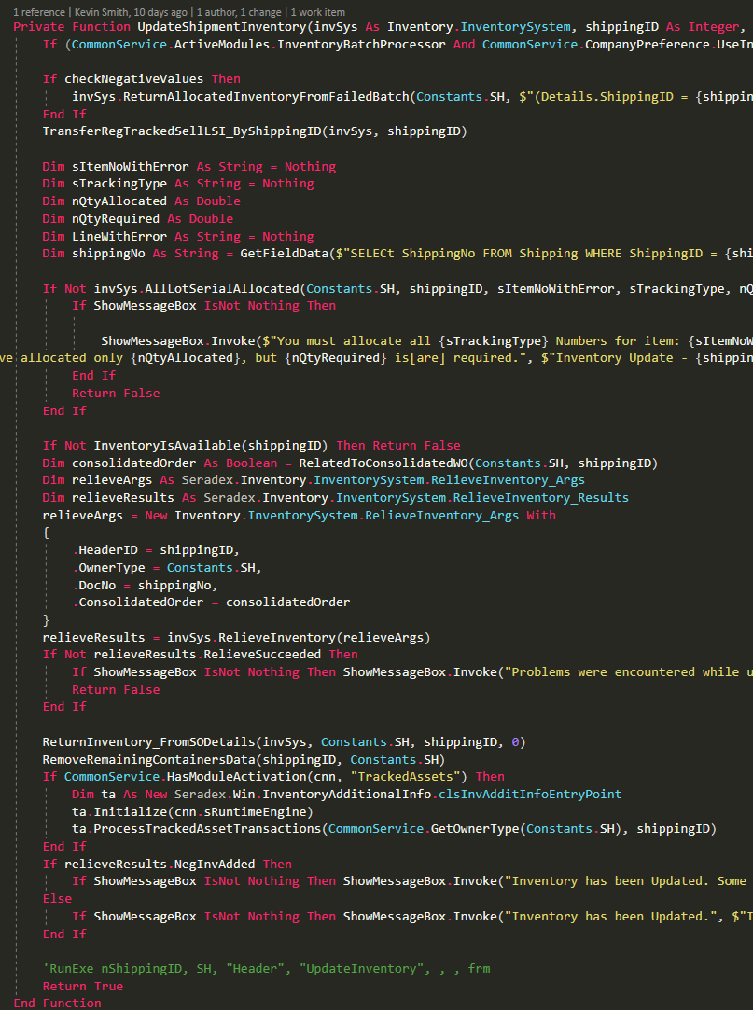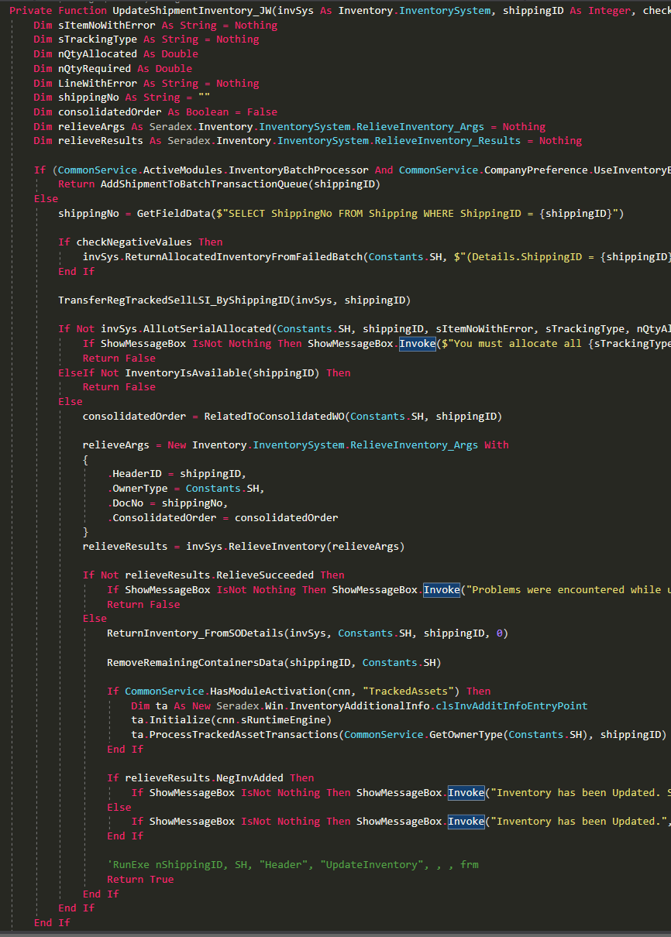

I did this instead:
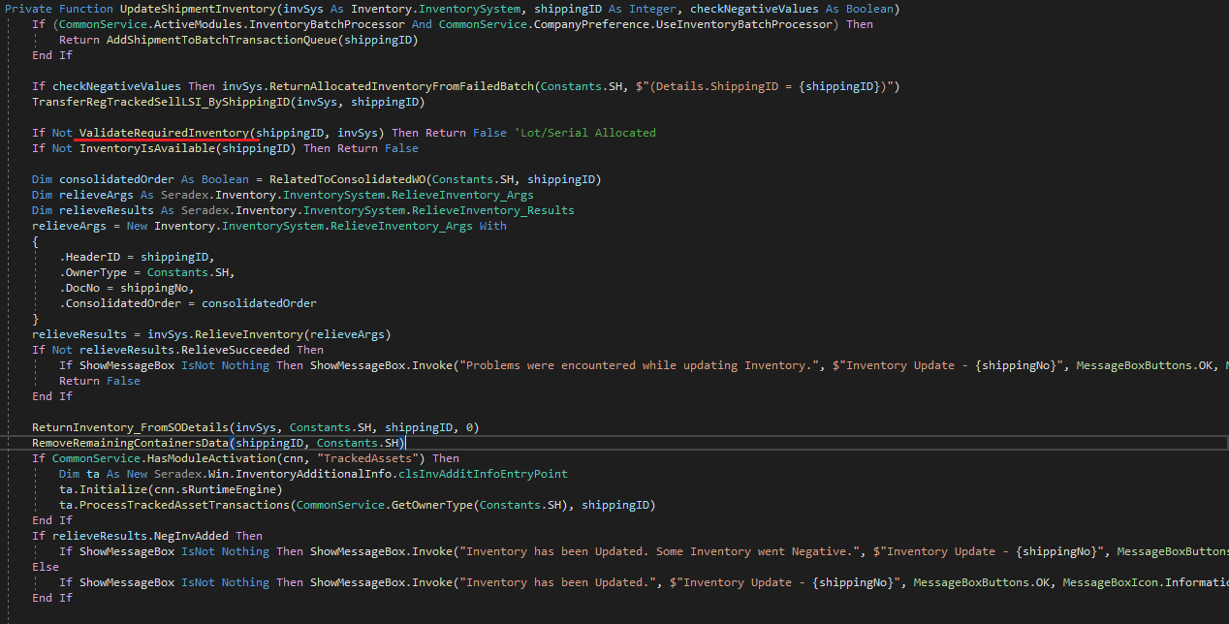
ValidateRequiredInventory existed and wrapped AllLotSerialAllocated, showing a message box. It was almost identical, so it is now used.
When you declare variables, memory is allocated. If the code will not use a variable, there is no need to allocate memory for it.
If there are multiple blocks declaring variables, it is a sign the function can/should be split up.
With the function in its new state, I don’t feel it’s worth splitting the top into a separate function. At least now there is only one block of declarations.

This makes it a little easier to see the general flow of the method.
Comments (Useful, explains why rather than how)
Message Boxes (Grammar, spelling, captions, appropriate icons)
- Some standard sxCapitalization:
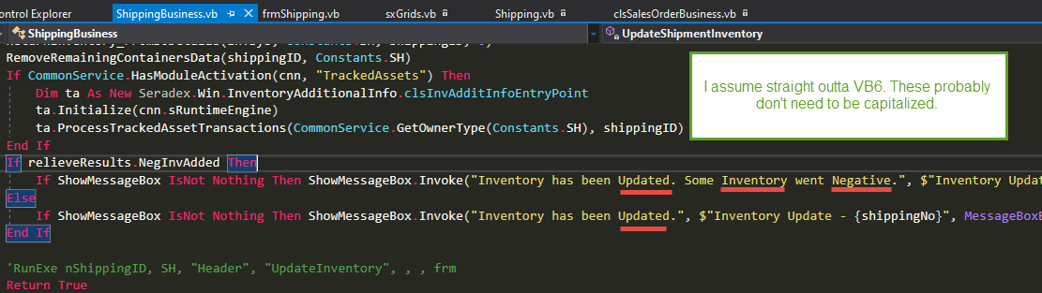
Capitalization has been fixed.
- Minor msgbox improvement(also, not sure if it’s possible, but if nQtyAllocated is 0, that would be an awkward statement. ‘You have allocated only 0…’ Perhaps only say ‘only’ if non-zero allocated):
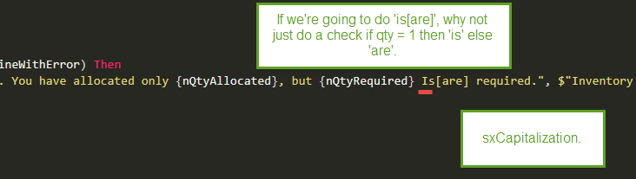
This message has been redone:
Current:
- You must allocate the required {sTrackingType} for item ""{sItemNoWithError}"" on line {LineWithError}. You have allocated only {nQtyAllocated}, but have specified that {nQtyRequired} {sSQL} needed.
New:
- You must allocate the required {sTrackingType} for item ""{sItemNoWithError}"" on line {LineWithError}. You have allocated {nQtyAllocated}, but require {nQtyRequired}.

sSQL used to be an is/are, but is no longer required.
sTrackingType used to be “Inventory” or “ Numbers”, and is now “inventory” or “quantity”.
“inventory” is used for regular tracked inventory. “quantity” is now used for lot/serial tracked.
I don’t know why a distinction is made.

Ticket Management(Release Branch?, Testing Notes)
Extras
- Not your code here, but this looks to be a bug in the Approval method. SetChanged() should be moved out of the Finally. We shouldn’t be calling SetChanged if Save fails. Might as well change it now.
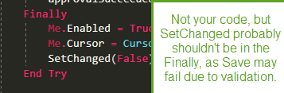
Removed
- Nit: Loading data before it’s required and before a potential abort condition:
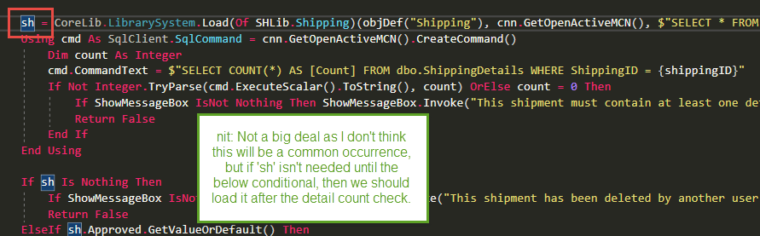
Moved

- Nit: Line spacing. I also don’t see where the nSOStatus is used. If it’s a default, then maybe it should be set in the Dim statement.
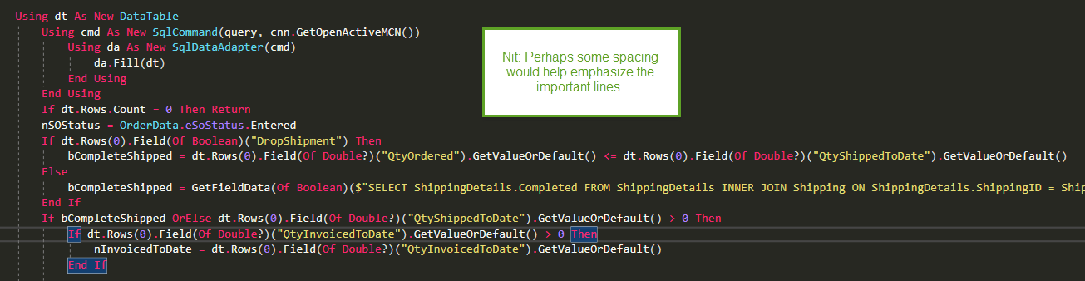
It is used at the bottom in an update statement.

